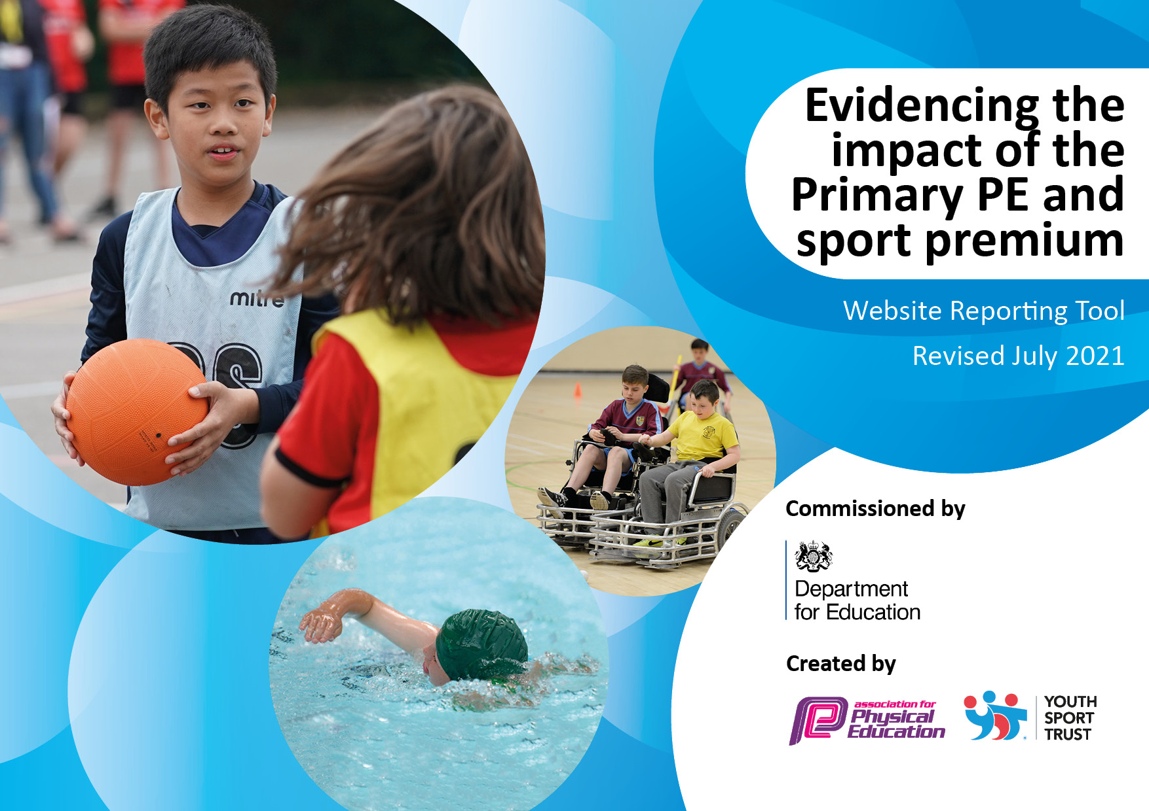
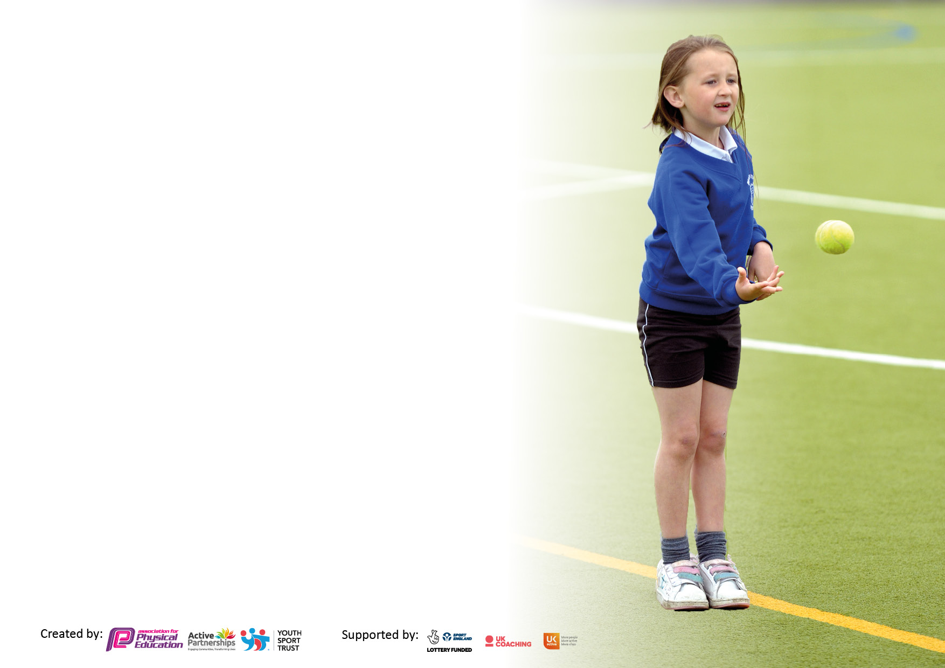

It is important that your grant is used effectively and based on school need. The Education Inspection Framework makes clear there will be a focus on ‘whether leaders and those responsible for governors all understand their respective roles and perform these in a way that enhances the effectiveness of the school’.

Under the Quality of Education Ofsted inspectors consider:
Intent - Curriculum design, coverage and appropriateness
Implementation - Curriculum delivery, Teaching (pedagogy) and Assessment
Impact - Attainment and progress

To assist schools with common transferable language this template has been developed to utilise the same three headings which should make your plans easily transferable between working documents.

Schools must use the funding to make additional and sustainable improvements to the quality of Physical Education, School Sport and Physical Activity (PESSPA) they offer. This means that you should use the Primary PE and sport premium to:

- Develop or add to the PESSPA activities that your school already offer
- Build capacity and capability within the school to ensure that improvements made now will benefit pupils joining the school in future years
- The Primary PE and sport premium should not be used to fund capital spend projects; the school’s budget should fund these.

Pleasevisitgov.ukfortherevisedDfEguidanceincludingthe5keyindicatorsacrosswhichschoolsshoulddemonstrate animprovement.Thisdocumentwillhelpyoutoreviewyourprovisionandtoreportyourspend.DfEencouragesschools to use this template as an effective way of meeting the reporting requirements of the Primary PE and sport premium.

We recommend you start by reflecting on the impact of current provision and reviewing the previous spend.

Schools are required to publish details of how they spend this funding, including any under-spend from 2019/2020, as well as on the impact it has on pupils’ PE and sport participation and attainment. All funding must be spent by 31st July 2022.

We recommend regularly updating the table and publishing it on your website throughout the year. This evidences your ongoing self-evaluation of how you are using the funding to secure maximum, sustainable impact. Final copy must be posted on your website by the end of the academic year and no later than the 31st July 2021. To see an example of how to complete the table please click HERE.

Details with regard to funding
Please complete the table below.

Total amount carried over from 2019/20 | N/A
Total amount allocated for 2020/21 | N/A
How much (if any) do you intend to carry over from this total fund into 2021/22? | N/A
Total amount allocated for 2021/22 | N/A
Total amount of funding for 2021/22. To be spent and reported on by 31st July 2022. | N/A
Swimming Data
Please report on your Swimming Data below.

Meeting national curriculum requirements for swimming and water safety.

N.B. Complete this section to your best ability. For example you might have practised safe self-rescue techniques on dry land which you can then transfer to the pool when school swimming restarts.
Due to exceptional circumstances priority should be given to ensuring that pupils can perform safe self rescue even if they do not fully meet the first two requirements of the NC programme of study
What percentage of your current Year 6 cohort swim competently, confidently and proficiently over a distance of at least 25 metres?  N.B. Even though your pupils may swim in another year please report on their attainment on leaving primary school at the end of the summer term 2020.  Please see note above | Numbers to be confirmed
What percentage of your current Year 6 cohort use a range of strokes effectively [for example, front crawl, backstroke and breaststroke]?  Please see note above | Numbers to be confirmed
What percentage of your current Year 6 cohort perform safe self-rescue in different water-based situations? | Numbers to be confirmed
Schools can choose to use the Primary PE and sport premium to provide additional provision for swimming but this must be for activity over and above the national curriculum requirements. Have you used it in this way? | Yes

Action Plan and Budget Tracking
Capture your intended annual spend against the 5 key indicators. Clarify the success criteria and evidence of impact that you intend to measure to evaluate for pupils today and for the future.

Academic Year: 2020/21 | Total fund allocated: £13,500 | Date Updated: September 2021
Key indicator 1: The engagement of all pupils in regular physical activity – Chief Medical Officers guidelines recommend that primary school pupils undertake at least 30 minutes of physical activity a day in school |  |  |  | Percentage of total allocation:
 |  |  |  | 1.8%
Intent | Implementation |  | Impact
Your school focus should be clear what you want the pupils to know and be able to do and about  what they need to learn and to  consolidate through practice: | Make sure your actions to achieve are linked to your intentions: | Funding allocated: | Evidence of impact: what do pupils now know and what can they now do? What has changed? | Sustainability and suggested next steps:
To provide pupils with appropriate area to undertake the recommended amount of physical activity. | Rent local public basketball and tennis courts for the academic year. | £300 | Medium term planning incorporates opportunities to use the facilities on a regular basis in the Spring and Summer terms.  All pupils are able to access sports which lend themselves to these facilities (e.g. tennis) as well as having the opportunity to use the MUGA (Multi Use Games Area).  Update: Facilities used effectively during tennis and netball units. | Aim to use the facilities whenever the weather allows during the Spring and Summer terms – the space provides the children with more opportunities to access a range of different sporting activities.  Medium term plans from previous year to be adapted to maximise the use of these facilities.
Key indicator 2: The profile of PESSPA being raised across the school as a tool for whole school improvement |  |  |  | Percentage of total allocation:
 |  |  |  | 16.4%
Intent | Implementation |  | Impact
Your school focus should be clear what you want the pupils to know and be able to do and about  what they need to learn and to  consolidate through practice: | Make sure your actions to achieve are linked to your intentions: | Funding allocated: | Evidence of impact: what do pupils now know and what can they now do? What has changed?: | Sustainability and suggested next steps:
To provide children with opportunities to engage in purposeful and varied physical activity during break and lunch times. | To install a ‘trim trail’ in a section of the playground during October half term. | £2500  Actual Spend:  £2709 | Children will be able to use the trim trail at both lunch and break times. This allows them to be more ‘adventurous’ with their play and use a range of movements they could not previously use on the playground.  Update: Trim trail successfully installed. Very popular amongst children according to pupil voice carried out by student council. | Trim trail to be monitored during break times and lunch times to measure effective use.  Trim trail to be regularly maintained to ensure children’s safety and that it does not fall into disrepair like previous installation.

Key indicator 3: Increased confidence, knowledge and skills of all staff in teaching PE and sport |  |  |  | Percentage of total allocation:
 |  |  |  | 47.1%
Intent | Implementation |  | Impact
Your school focus should be clear | Make sure your actions to | Funding | Evidence of impact: what do | Sustainability and suggested
what you want the pupils to know | achieve are linked to your | allocated: | pupils now know and what | next steps:
and be able to do and about | intentions: |  | can they now do? What has
what they need to learn and to |  |  | changed?:
consolidate through practice:
Children to be provided with the opportunity to take part in high quality PE lessons.  To provide sports coach with resources to support them in planning and delivering their curriculum PE lessons. | Sports coach employed to deliver high quality PE lessons and share expertise with teaching staff who are responsible for their own PE lessons.  Subscription to be renewed to continue to develop sports staff knowledge and understanding when planning, delivering and assessing all classes in PE. | £6000  Actual Spend:  £7125  £370  Actual Spend:  £650 | All children access high quality PE lessons across the school, delivered by sports coach. Throughout the year, staff are supported by our coach in delivering their own PE lessons when necessary.  Update: School to employ new sports coach directly from September to carry out the same duties as the previous coach.  Pupils accessing higher quality and better structured lessons delivered by their class teacher. Curriculum coverage has also improved further. | Sports coach to deliver curriculum lessons throughout the year and to take on some of the responsibility of PE leader including assessment and preparation of children for competitive sport.  Sports staff to continue delivering sessions across the curriculum using the scheme with a view to using the assessment tool termly across all years.
Key indicator 4: Broader experience of a range of sports and activities offered to all pupils |  |  |  | Percentage of total allocation:
 |  |  |  | 26.7%
Intent | Implementation |  | Impact
Your school focus should be clear | Make sure your actions to | Funding | Evidence of impact: what do | Sustainability and suggested
what you want the pupils to know | achieve are linked to your | allocated: | pupils now know and what | next steps:
and be able to do and about | intentions: |  | can they now do? What has
what they need to learn and to |  |  | changed?:
consolidate through practice:
To provide children with the opportunity to experience sporting activities delivered by a specialist and to promote participation in these areas.  Children to be provided with high quality resources to use during their PE lessons and break time activities.  Children to be provided with safe and high quality gymnastics equipment.  Opportunities for year 6 children to become more confident in water and challenge themselves to become better swimmers. | Book sessions with a specialist dance teacher and martial arts instructor for all classes during the year.  New resources to be purchased to replace any items that have become damaged as a result of general wear and tear.  Other equipment to be purchased in order to meet the demands of the curriculum and to ensure lessons are well-resourced.  Gymnastics equipment (wall mounted apparatus and safety mats) to be checked annually to ensure it meets the correct safety regulations.  Additional swimming sessions on top of the general curriculum sessions offered earlier in the year. Provided by specialist swimming teachers at local leisure centre. | £1500  Actual Spend:  £0  £2000  Actual Spend:  £2526  £250  Actual Spend:  £110  £2000  Actual spend:  £1764 | Children will have access to two specialist teachers for sessions which will either develop their current skills or build their interest in these areas.  Update: Money saved and dance sessions delivered by PE coach. Martial arts sessions to be booked in for next academic year.  Resources used regularly in PE lessons by sports coach to ensure the delivery of high quality physical activity.  Resources used by sports leaders and additional sports coaches during organised activities at break and lunch times.  Equipment used by staff during PE lessons in the Autumn term and sports coach during after school clubs.  Sessions to take place later in the academic year following SATs. | If successful, specialists will be invited back each year and will potentially support staff in their own delivery of PE lessons as well as delivering sessions to all children.  To regularly check equipment to ensure it is in a good enough condition to be used effectively.  To ensure most resources are used regularly as part of a broad school PE curriculum.  To continue to plan for opportunities for equipment to be used in PE lessons during the year.  Analysis of key children to be undertaken by swimming teaching staff during initial swimming sessions during the Spring term.

Key indicator 5: Increased participation in competitive sport |  |  |  | Percentage of total allocation:
 |  |  |  | 9.2%
Intent | Implementation |  | Impact
Your school focus should be clear | Make sure your actions to | Funding | Evidence of impact: what do | Sustainability and suggested
what you want the pupils to know | achieve are linked to your | allocated: | pupils now know and what | next steps:
and be able to do and about | intentions: |  | can they now do? What has
what they need to learn and to |  |  | changed?:
consolidate through practice:
School to attend local sporting competitions within our cluster to provide children with the experience of a competitive sporting scenario.  Provide the children with a suitable area to take part in inter-house sports day.  To provide the children with rewards and a sense of achievement following sports day.  To provide children with safe access to sports festivals outside both the school premises and hours.  Total allocated: £16500  Estimate: £16390  Actual: £16702 | Clubs and trials will be provided in the weeks leading up to the festivals to prepare children for the competition.  School to attend a larger number of festivals outside the cluster provided by our local school sports partnership. Costs will include the transportation of children to and from competition venues as well as entry costs to some of the competitions.  Running track to be marked out by the council in preparation for sports day.  Trophies and medals to be purchased and certificates to be created to present to both individual winners and house teams on sports day.  School phone to be used by staff and taken to festivals throughout the year in order to be able to communicate with both parents and staff back at school. | £1000  Actual Spend:  £1022  £150  Actual Spend: £165  £200  £120  Actual Spend:  £131 | Festivals in both the local cluster and the school sports partnership are planned and will commence from September onwards.  Update: Total of 32 festival events attended across the cluster and SSP programmes.  Sports day planned in for the summer term to promote competition, sportsmanship and other sporting values.  Following the success of last year, track to be marked out twice to ensure an adequate amount of time for children to practise their events.  The profile of sports day and PE in general will continue to be raised and every child across all year groups will take part in all events on sports day.  Phone to be used in the event of medical issues and late parent collections when necessary. | To continue to promote competitive sport by participating in festivals.  To organise clubs for children to take part in prior to the festivals to ensure festival attendance.  To continue review the organisation of sports day year on year.  New medals and certificates to be purchased and created for next year. Trophy to continue to be reused and engraved for the winning house year on year.  Phone to continue to be used in the next academic year and beyond.

Signed off by
Head Teacher:
Date:
Subject Leader:
Date:
Governor:
Date:

